Lab 07: Sequence Diagrams for Understanding Systems
Team Members: Myles Sartor, Brandon Weber, Zachary Silver

Activity Instructions
The instructions can be found in the Assignment in Canvas.

Questions For Reporting Back
Fill in these questions with the responses that you came up with as a team or that we discussed as a class.
- Sequence Diagrams (Insert your photos):
  - Your version of the 3-actor example
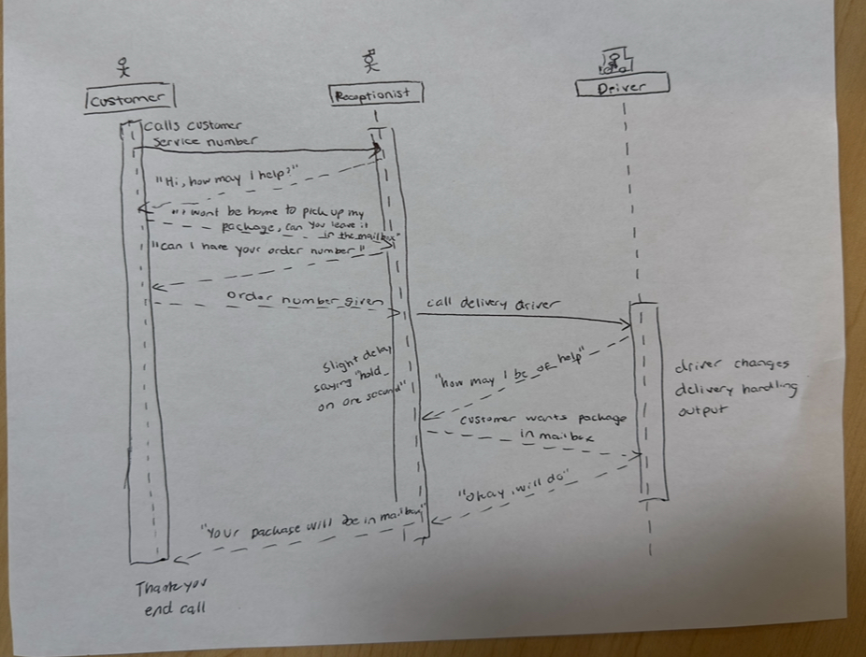

  - Your version of the 7-actor example

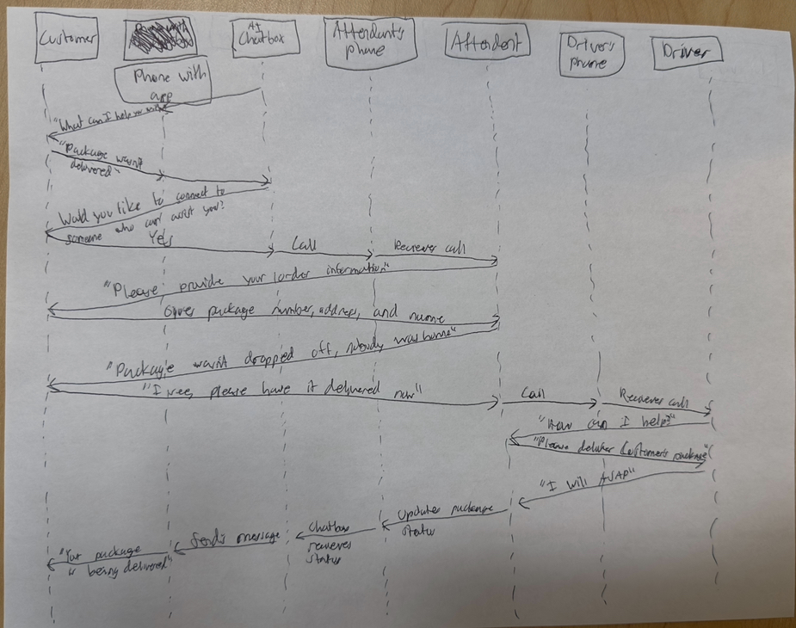

- Short Video (Insert a link to the video)
https://share.icloud.com/photos/0d4gJCnUp3-kjClfR2eH0Cl6w
https://share.icloud.com/photos/093_2iDTrpdMb3ZSFrLMHu9Uw

- Reflect on how sequence diagrams might be useful in your future intended career. Each person shares their thoughts on the practical applications of understanding and using sequence diagrams in your field.
  - Team Member Name: Francis Vo
Sequence diagrams can help in data science by showing how systems interact step by step and how data flows through users, applications, and systems.

  - Team Member Name: Brandon Weber
Sequence diagrams may be useful in my career to understand how different systems are interacting with one another. This is important in any tech field.

  - Team Member Name: Myles Sartor
Sequence diagrams are viable means of documenting the process behind the implementation of the coding that goes into the application development for different companies.

  - Team Member Name: Zachary Silver
Sequence diagrams can help explain the complicated network processes that occur in nanoseconds by breaking them down into a step-by-step process while also showing how each part of the system interacts with each other.

  - Team Member Name:

